**CESIUMJS ENTITY SIMULATION**

**Introduction**

The CesiumJS Entity Simulation project aims to create an interactive 3D environment where various objects, such as satellites and communication towers, are dynamically represented in real-time. The project uses CesiumJS, a powerful 3D geospatial mapping library, alongside Flask to serve as the backend for the web application. The main objective of this simulation is to visualize and display Very High Frequency (VHF), Ultra High Frequency (UHF), and High Frequency (HF) signals. This allows for a comprehensive understanding of the spatial dynamics involved in RF (radio frequency) communications.  
  
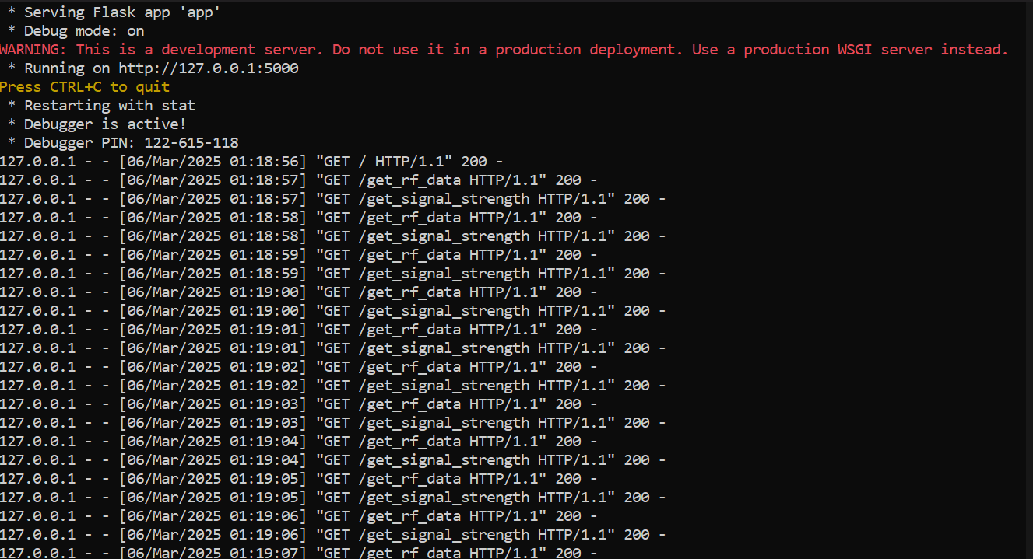

### **Features of the Project**

#### **1. Drag and Drop Functionality**

A key feature of this simulation is the implementation of a drag-and-drop functionality, enabling users to interact directly with 3D models in the CesiumJS environment. This feature allows users to intuitively place and position objects, such as satellites and towers, at specific coordinates in the virtual world.

* **Ease of Interaction:** Users can drag and drop objects into any location within the simulation, making it easy to model various RF communication scenarios.
* **Coordinate-based Placement:** In addition to dragging and dropping, users can specify exact coordinates for precise object placement. This ensures accurate simulation of RF communication setups, critical for applications involving VHF, UHF, and HF frequencies.  
    
  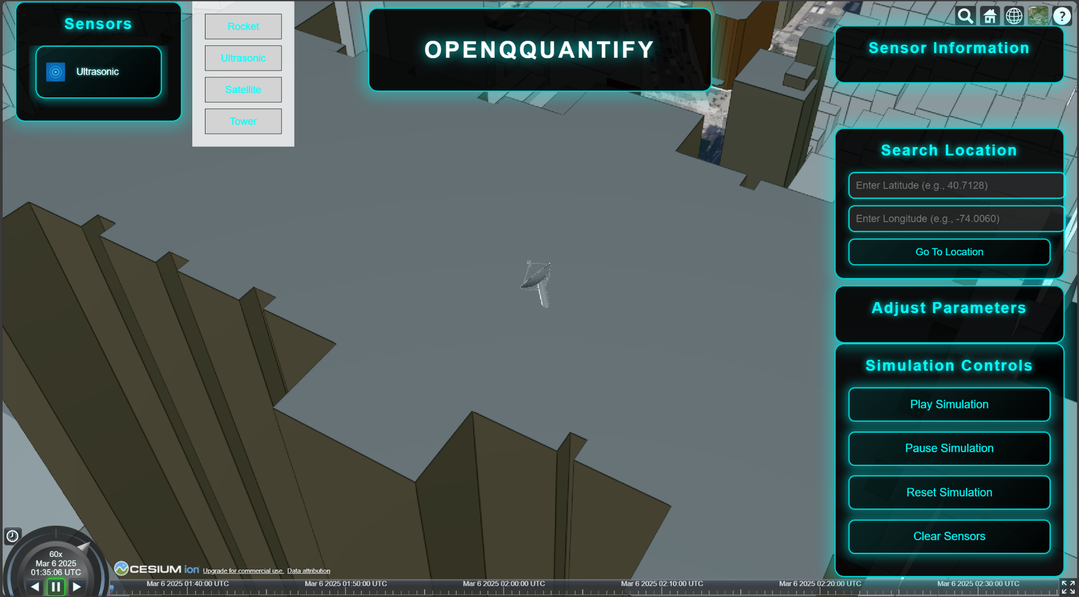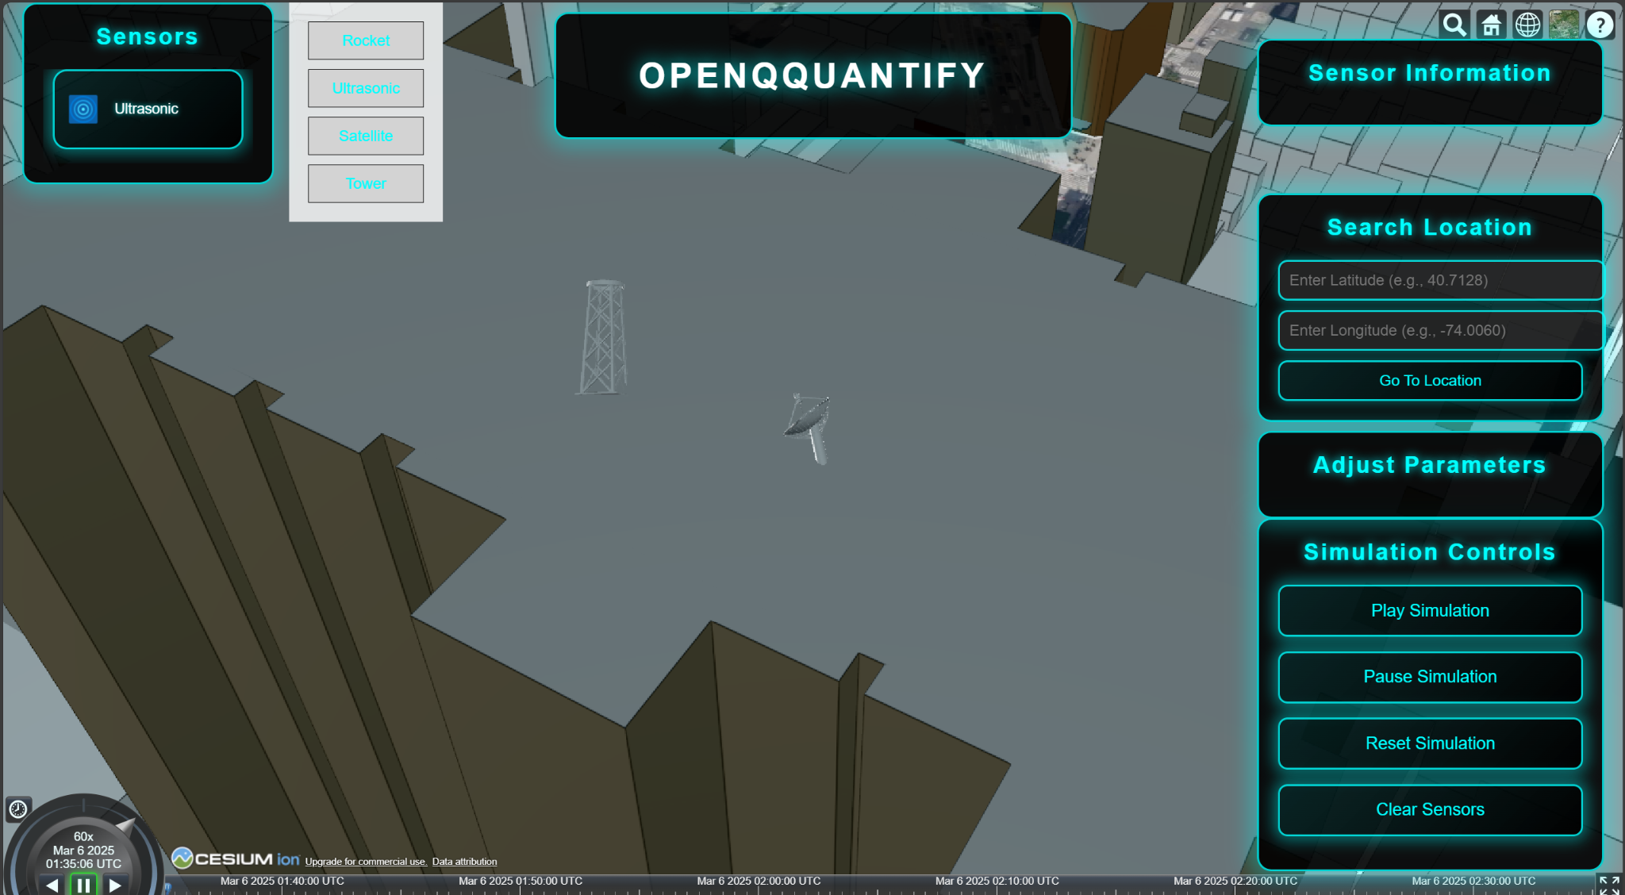

#### **2. Double Click Zoom Feature**

To improve user interaction and enhance object visibility within the simulation, a double-click zoom feature has been integrated. This functionality allows users to double-click on any object within the CesiumJS environment to zoom in and view it clearly.

* **Instant Zoom:** The double-click action zooms the camera directly to the selected object, providing a closer, more detailed view without the need for excessive cursor movement.
* **Improved Navigation:** This feature helps users navigate complex simulations where objects may be spread across vast virtual environments, ensuring that important elements are always easily accessible.

#### **3. Real-Time RF Signal Visualization**

The CesiumJS environment is used to visualize RF signal coverage in 3D space. This project focuses on the interaction of VHF, UHF, and HF signals, providing visual representations of the range and propagation of these frequencies.

* **RF Signal Mapping:** By leveraging CesiumJS's 3D terrain capabilities, users can view the impact of terrain, altitude, and geography on signal propagation.
* **Interactive Map:** Users can adjust parameters to simulate various signal strengths and frequencies, allowing for an interactive exploration of how different frequencies interact with the environment.

### **Conclusion**

The CesiumJS Entity Simulation provides a robust, user-friendly interface for visualizing complex RF communication scenarios in 3D space. Through features such as drag and drop functionality, double-click zoom, and real-time RF signal visualization, users can interact with and analyze simulations that involve various RF frequencies. This project, powered by Flask and CesiumJS, offers a powerful tool for engineers, researchers, and educators working in the field of RF communication.